**Name:Momna Khurram Qureshi**

**Sap ID:55430**

**Course:Computer Architecture Lab**

**Instructor Name:Mam Ayesha**

**Task 1:**

**Case 1:**

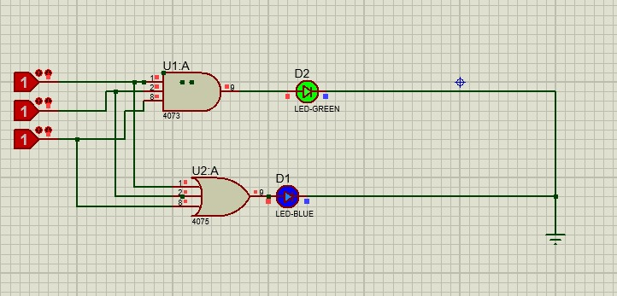

**Case 2:**

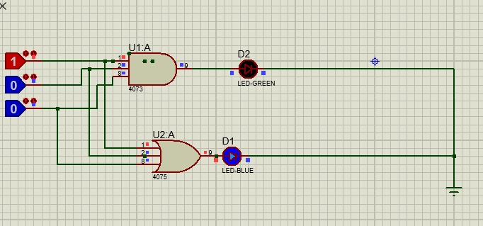

**Task 2:**

**Case 1:**

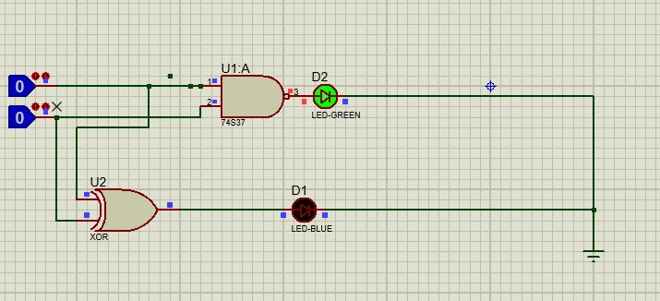

**Case 2:**

